**Solar Power in Australia: The current state of the nation**

**Team Members**

Dale Currigan, Helen Amin, Rajesh Nair, Ray Camo

**Background**

Solar photovoltaic (‘solar power’) generated 3.1 per cent of Australia’s electricity in 2016-17, the majority of which came from small-scale rooftop installation. More than two million, or 21 percent, of Australian households now have rooftop solar, with a combined capacity exceeding 10 GW. However, there remains huge potential on Australia’s remaining roofs, for the expansion of solar power, especially given our climate.

Federal solar incentives and rebates for solar installation have led to a rapid adoption of this technology in recent years. However, the factors that that lead to consumers adopting this technology, and how that might inform future measures to increase solar, remain less clear.

**Aims**

* Create a SQLite database of current and historical data, broken down by postcode, containing solar power installations, power generation, and factors that may influence the uptake of solar (e.g. household income, federal government solar rebates).
* Use this database to create a series of interactive data visualisations that describe the current state of home solar in Australia, as well as identifying areas of unmet potential and factors that may influence homeowner’s willingness to adopt this technology.

**Rationale**

Potential applications of this project could include:

* At a government level, allow the analysis of the rebate schemes success, and direct future initiatives and renewable energy policy.
* At the individual household level, allow consumers to see how their suburb compares to the nation and how solar has changed over time. Such information could promote further adoption of solar and could be used as a marketing tool.

**Datasets**

1. Australian Clean Energy Regulator - Postcode data for small-scale installations. 2001-2021 data, broken down by post code. Available at:

<http://www.cleanenergyregulator.gov.au/RET/Forms-and-resources/Postcode-data-for-small-scale-installations#Historical-data>

1. GeoJSON for Australian Suburbs. Will allow geospatial representations of the projects data. Available at:

<https://github.com/tonywr71/GeoJson-Data/blob/master/australian-suburbs.geojson>

1. Australian Database of Postcode and Suburb data. Postcode and suburb information for all suburbs in the above solar power dataset. Available at:

<https://www.matthewproctor.com/australian_postcodes>

1. Australian Bureau of Statistics. Taxation statistics dataset. Provides data on total income and total salary/wages, broken down by postcode. Available at: <https://data.gov.au/data/dataset/taxation-statistics-postcode-data/resource/b713d037-d9f5-49e5-a492-502cd7b3a15a>
2. Australian Clean Energy Regulator – Postcode zone ratings postcode zones for solar panel systems. Source of data on amount of federal government rebate provided by postcode. Available at:

<http://www.cleanenergyregulator.gov.au/DocumentAssets/Pages/Postcode-zone-ratings-and-postcode-zones-for-solar-panel-systems.aspx>

**Design**

The site will contain 3 pages as outlines below:

1. **Home page – Solar Dashboard**

* A dashboard containing Plotly and D3 visualisations of the solar data
* The user can search by suburb or postcode to display the corresponding data
* Planned visualisations:
  + Bar chart of output and installation numbers for each suburb, with comparisons to state and national average
  + Line chart of installations and output over time for that suburb
  + Scatter plot of installations/output vs income/rebate
  + Table summary of suburb info

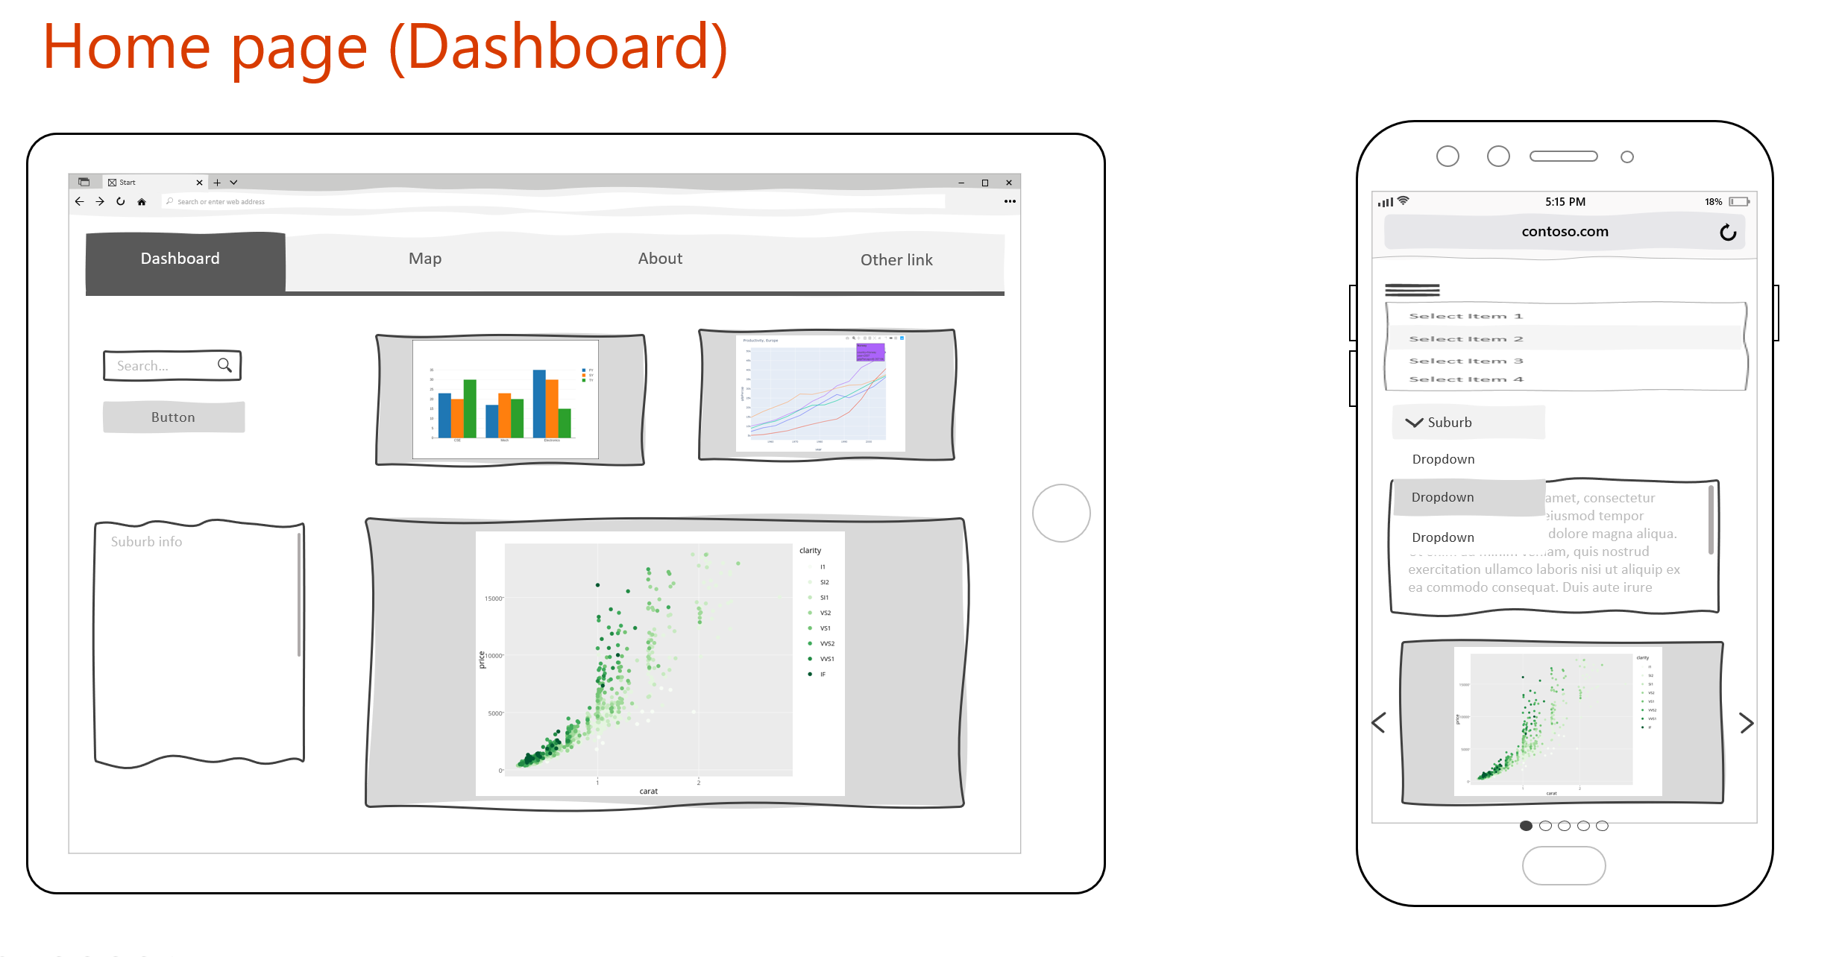

1. **Map page**

* Geospatial representation of output, installation, income and rebate data

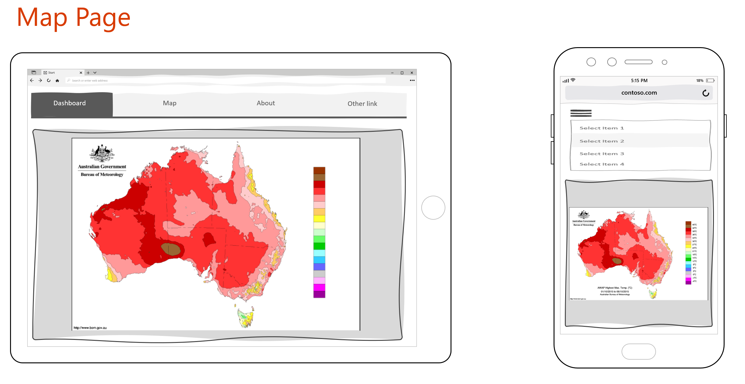

1. **About Page**

* Summary information on the dataset sources, project rationale, and team members

